CL-1002
Programming Fundamentals - Lab
Lab # 4
Objectives:
- Introduction to Visual Studio 2015.
- Debugging
- Step Through Code
- Break Points
- Practice tasks

Note: Carefully read the following instructions (Each instruction contains a weightage)

- Use proper font family and font size of heading, sub heading and normal text.
- First think about statement problem then write/draw your logic on copy.
- Write pseudocode of every task on paper (hard form).
- File tittle should in proper format (23F-1001-Lab2)
- Do not copy from any source otherwise you will be penalized with negative marks.
- Complete your lab within given Time Slot.

- Press Windows key and type “Visual Studio”
- Start new project
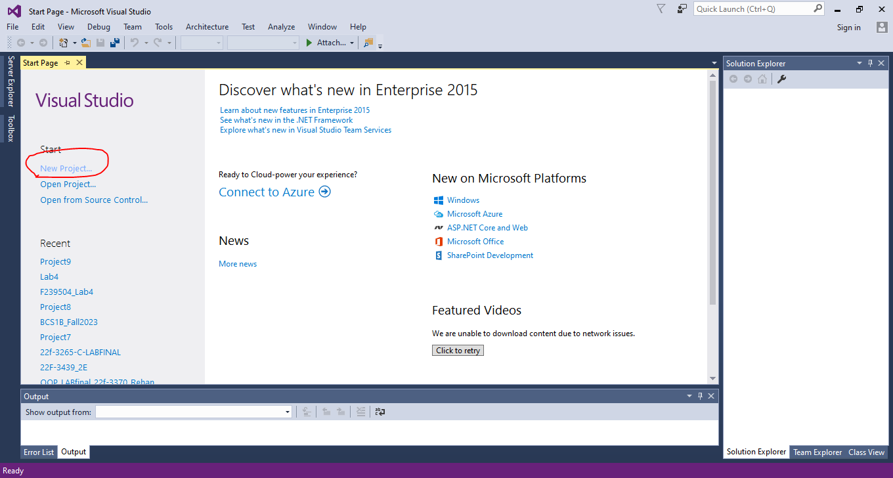
- Now select empty project for visual C++
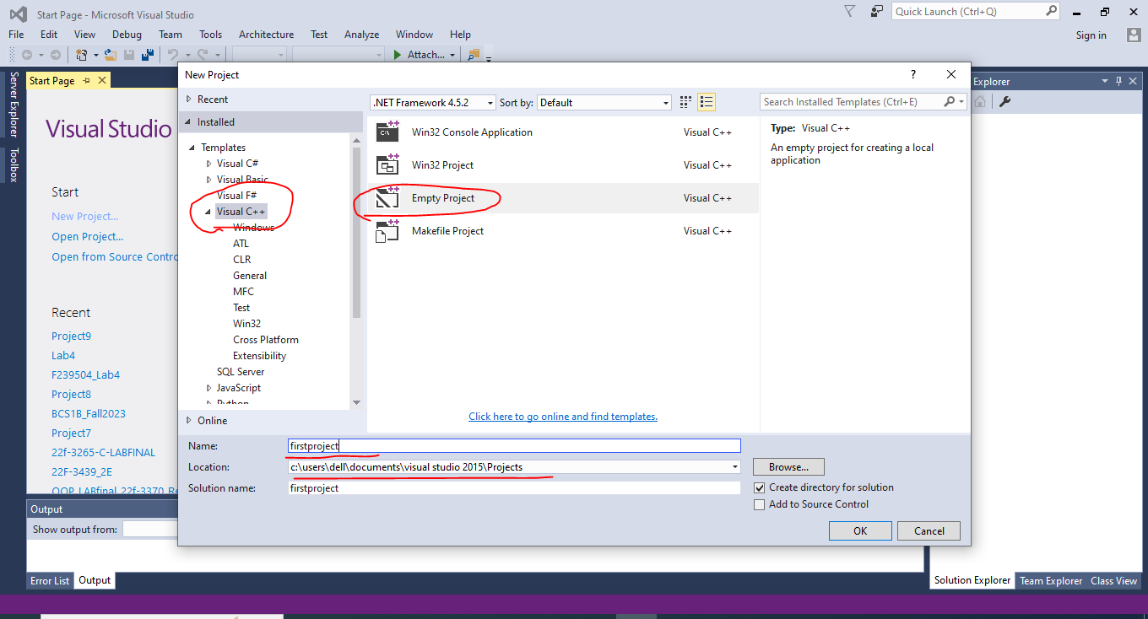
- Choose appropriate name and location for that project
- Right click on source files, then select Add and select New item
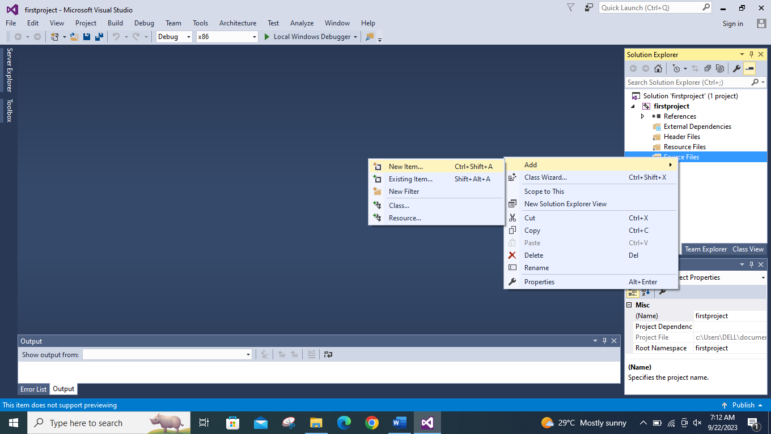
- Then select C++ source file (.cpp) and choose appropriate name
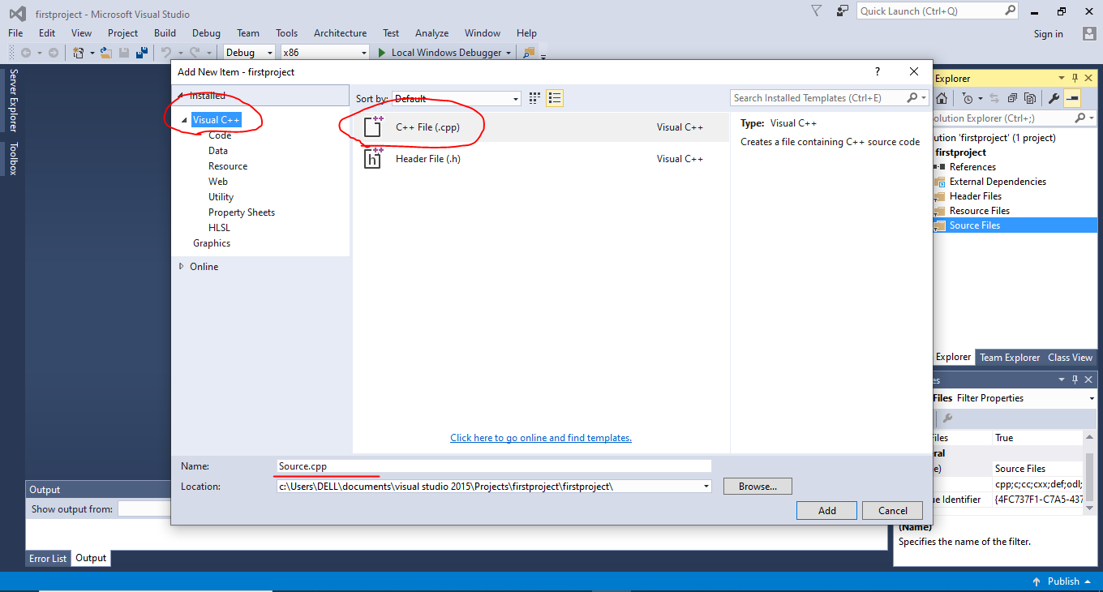
- Welcome to Visual Studio 2015. Write down your first executable program.
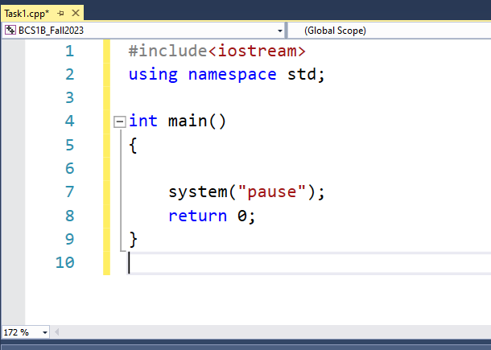

Coding Practice
1
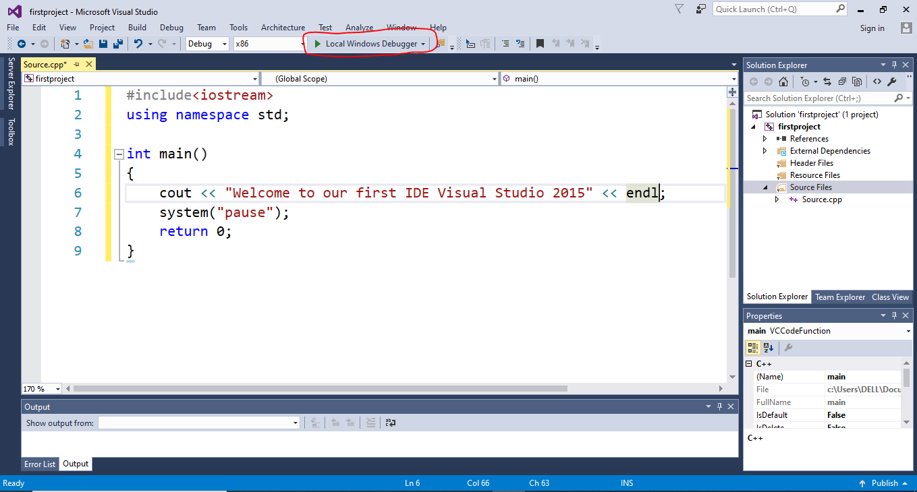
2
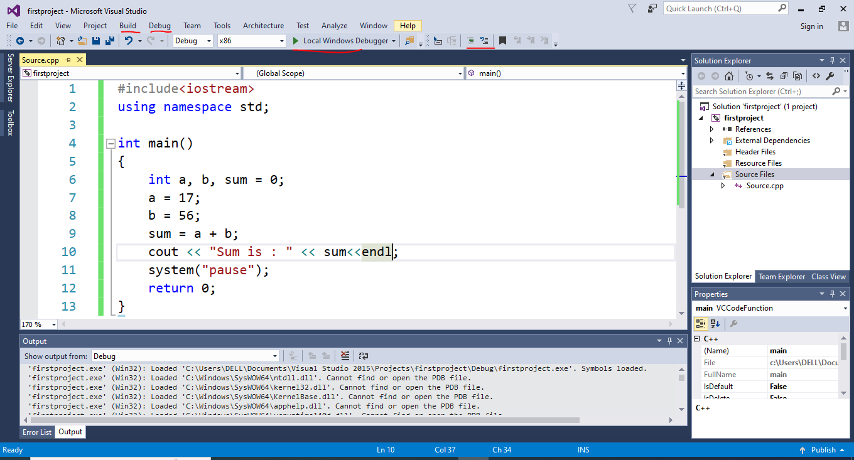
3
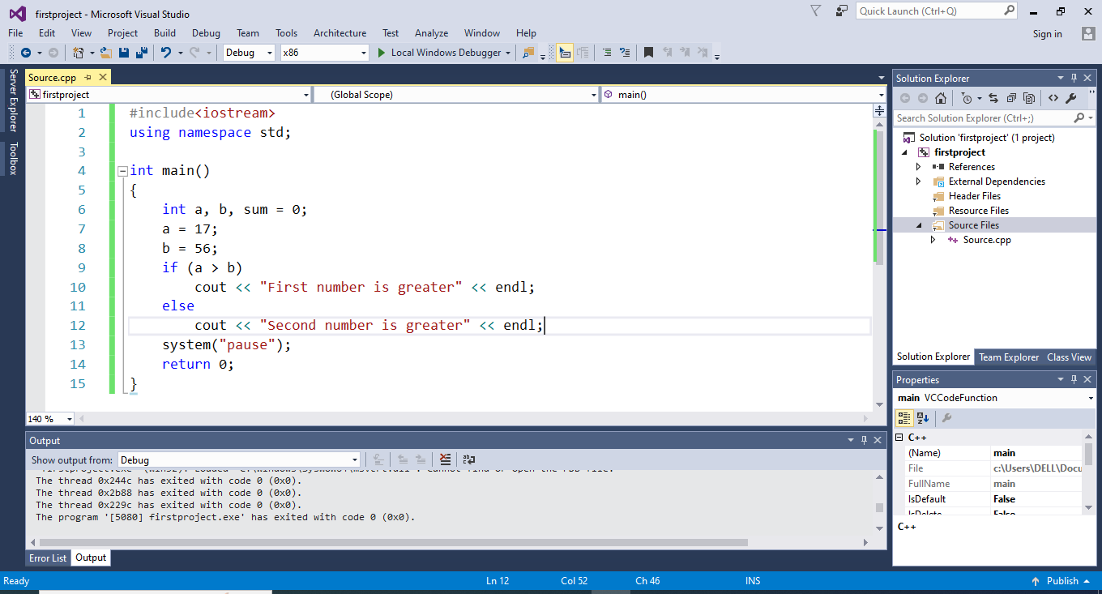
4
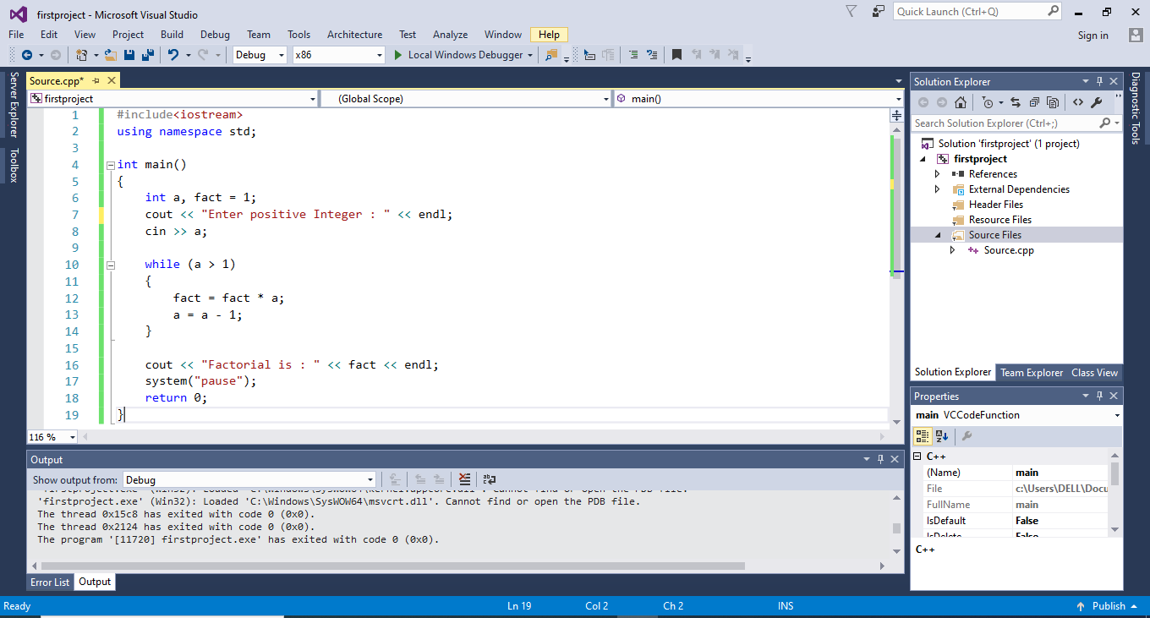
5
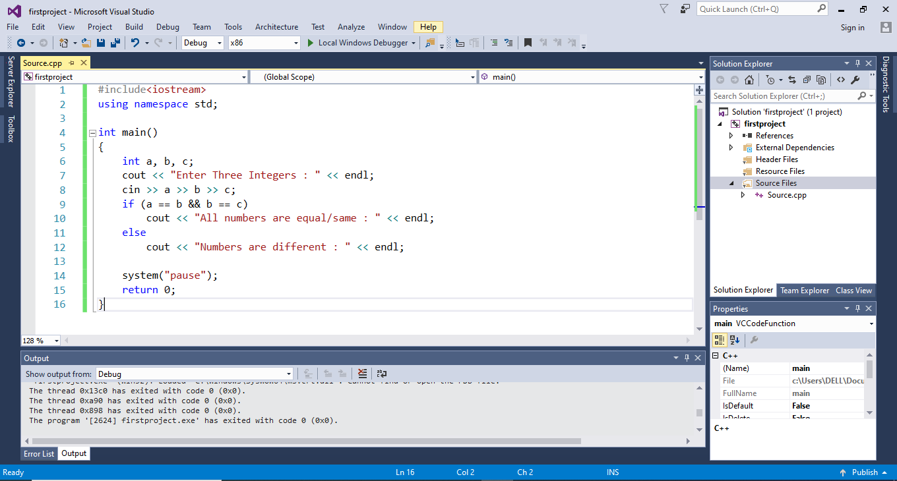

Problem: Write C++ code for the following statements
- Detail understanding of Visual Studio. (Marks 10)
- Create Project.
- Create multiple files
- Use of comments
- Build/rebuild project
- Step-into/over
- Breakpoints
- Open an existing project from it’s loctoin.

- J. announced some discount (flat 50%) on all its outlets. Take the original price of product from user, calculate the discounted price of one product. (Marks 01)
Hint: original price * discount / 100.

- A hostelite student wants to calculate his/her average bill of the year. Take 12 inputs (bill amount) from that student and show his/her average. (Marks 01)
Hint: average = sum of bill/total months

- A programming fundamental – lab consists of 10 tasks. Each task carries 5 marks. If a student solved more than 8 tasks then instructor gives him/her some extra points (5 marks additional for each task). Create a program, that asks student how many tasks he/she has solved and calculate marks.
Hint: 8*5 = 40. If extra 10 + 10 = 60 (Marks 01)

- Write a program to take weather and determine the condition of weather on the following conditions: (Marks 01)
- Weather is greater than 45, Sunny
- Weather is greater than 20, Rainy
- Weather is less than or equal to 20, Fog
- Otherwise, False input

- Write a C++ program to check whether a character is Vowel or Consonant. (using AND,OR operator) (Marks 01)

- Write a C++ program for an activity that takes a user's input (1-7) and displays the corresponding day of the week. (Marks 2.5)
- Monday
- Tuesday
- Wednesday
- Thursday
- Friday
- Saturday
- Sunday

- Create a flowchart and pseudocode/algorithm to pass Programming Fundamentals - Lab.
Marks Distribution: (Marks 2.5)
- Lab- 40 Marks
- Final Exam- 40 Marks
- Project- 15 Marks
- Class Participation- 05 Marks
- Total- 100 Marks
Apply the grading scheme on total marks and show the relevant grades.
<30 - F
30 to 39 - D
40 to 44 - D+
45 to 49 - C-
50 to 54 - C
55 to 59 - C+
60 to 64 - B-
65 to 69 - B
70 to 74 - B+
75 to 79 - A-
80 to 85 - A
>85 - A+

---------------------------------------------------------------------------
Best of Luck 
“Learning is never done without errors and defeat” – Vladimir Lenin

